Safety Screening Form for
Magnetic Resonance (MR) Procedures
Date ___________________________
Name (First, Middle, Last): ______________________________________________________________________
Gender: □Male □Female Age _______ Date of Birth_____________________________
Height: ___________ Weight___________

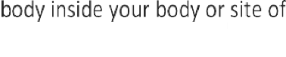
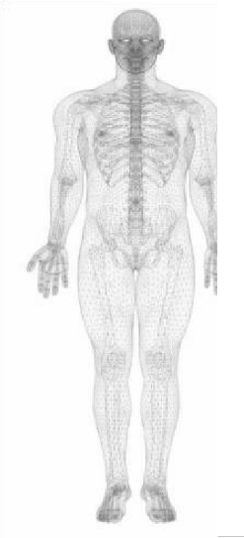
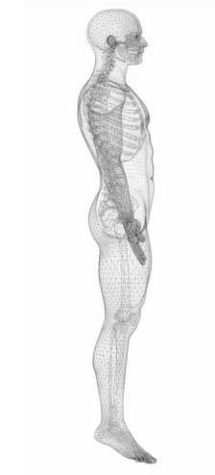
If uncertain of any answer, please circle and leave blank to discuss with the technologist.

Yes shrapnel)
No Injury by a metal object or foreign body (e.g., bullet, BB,

If yes, explain:

Yes No Injury to your eye from a metal object

Yes No If yes, did you seek medical assistance?

If yes, describe what was found:

Yes No Foreign body removed from eye

If yes, describe what was taken out:

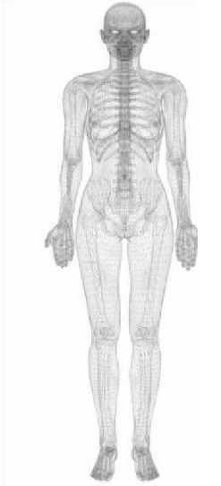
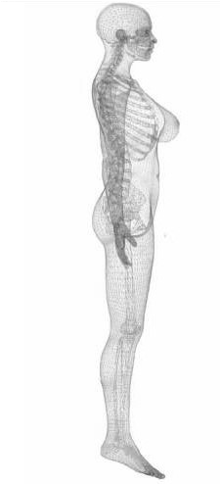
Yes No Spinal fusion procedure

Yes No Endoscopy or colonoscopy in last 30 days

The following items may be harmful to you during your MR scan and may interfere with the MR exam.

Please indicate if you CURRENTLY HAVE or HAVE EVER HAD any of the following:

Surgically implanted medical devices

- □ Yes □ No Any type of electronic, mechanical or magnetic implant
If yes, list type: ___________________________________________________________________________
- □ Yes □ No Cardiac pacemaker, defibrillator, or other cardiac implant (in place or removed)
- □ Yes □ No Aneurysm Clip
- □ Yes □ No Neurostimulator, diaphragmatic stimulator, deep brain stimulator, vagus nerve stimulator, bone growth stimulator, spinal cord stimulator, or any biostimulator (in-place or removed)
If yes, list type: ___________________________________________________________________________
- □ Yes □ No Any type of internal electrodes or wires
- □ Yes □ No Cochlear implant
- □ Yes □ No Implanted drug pump (e.g., insulin, baclofen, chemotherapy, pain medicine)
- □ Yes □ No Spinal fixation device
- □ Yes □ No Any type of coil, filter, or stent
If yes, list type: ___________________________________________________________________________
- □ Yes □ No Artificial heart valve
- □ Yes □ No Any type of ear implant
- □ Yes □ No Artificial eye
• □ Yes □ No Penile implant
- □ Yes □ No Eyelid spring and/or eyelid weight
- □ Yes □ No Any type of implant held in place by a magnet
- □ Yes □ No Any type of surgical clip or staple
- □ Yes □ No Any IV access port (e.g., Broviac, Port-a-Cath, Hickman, PICC line)
- □ Yes □ No Shunt
If yes, type: ______________________________________________________________________________
- □ Yes □ No Tissue Expander (e.g., breast)
- □ Yes □ No IUD
If yes, type: ______________________________________________________________________________
- □ Yes □ No Surgical mesh
If yes, location: ___________________________________________________________________________
- □ Yes □ No Radiation seeds
- □ Yes □ No Any implanted items (e.g., pins, rods, screws, nails, plates, wires)

Removable medical devices

- □ Yes □ No Hearing aid
- □ Yes □ No Removable drug pump (e.g., insulin, Baclofen, Neulasta)
- □ Yes □ No Any type of ear implant
- □ Yes □ No Artificial eye
- □ Yes □ No Any type of implant held in place by a magnet
- □ Yes □ No Artificial limb
If yes, what and where: ________________________________________________________________
- □ Yes □ No Medication patch (e.g., nitroglycerine, nicotine)
- □ Yes □ No Removable dentures, false teeth or partial plate
- □ Yes □ No Diaphragm, pessary
If yes, type: ________________________________________________________________________________
- □ Yes □ No Have you recently ingested a “pill cam?”
If yes, date “pill cam” was ingested? ___________

Personal

- □ Yes □ No Body piercings
- □ Yes □ No Wig, hair implants
- □ Yes □ No Tattoos or tattooed liner
- □ Yes □ No Any hair accessories (e.g., bobby pins, barrettes, clips, extensions, weaves)
- □ Yes □ No Jewelry
- □ Yes □ No Metal-containing clothing material and/or underwear
- □ Yes □ No Magnetic cosmetics and hair care (e.g., magnetic eyelashes, magnetic nail polish)
- □ Yes □ No Electronic monitoring or tagging equipment (e.g., ankle monitor)
- □ Yes □ No Fitness tracker/bio monitor (e.g., Fitbit)
- □ Yes □ No Any other type of surgically implanted devices, removable medical devices or personal items not covered above?
If yes, type: ________________________________________________________________________________

I have read and understand the entire content of this form.

Patient signature:

MD/RN/RT signature: _

